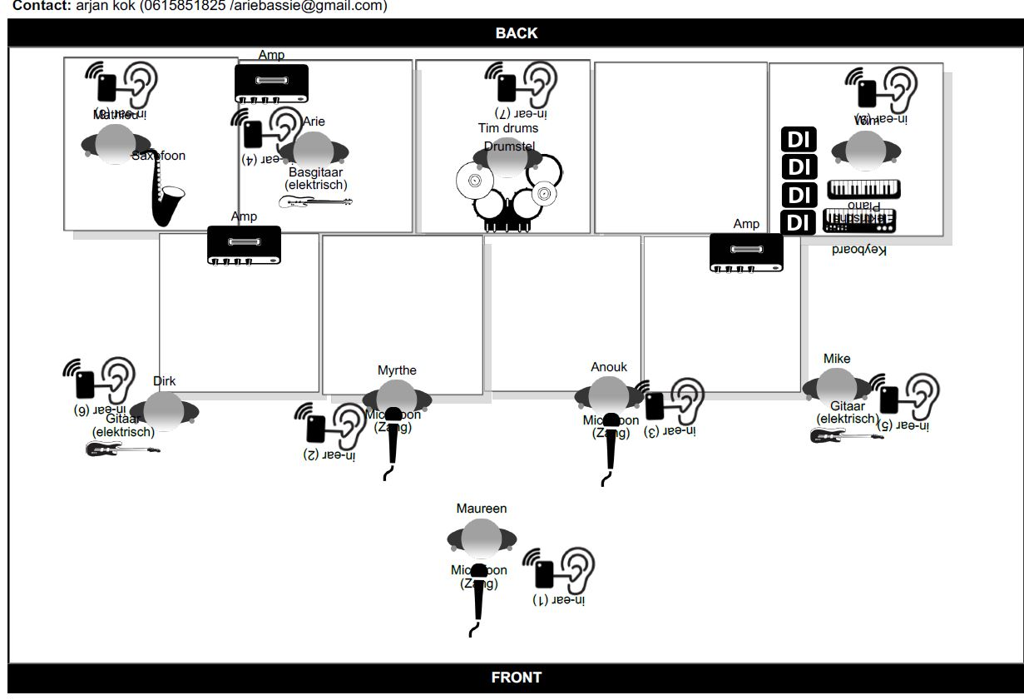
This is TINA stageplan 2024/25

MAUREEN LEADVOCALS DIRK RHYTHM GUITAR, STAGE RGHT
NOOKE BACKING VOCAL 1 MATHIEU SAXOPHONE, STAGE RIGHT
MYRTHE BACKING VOCAL 2 WIM KEYBOARD,STAGE LEFT
TIM DRUMS ARIE BASSGUITAR, STAGE RIGHT
MIKE LEADGUITAR, STAGE LEFT

IMPORTANT NOTES:
LEAD AND BACKING VOCALS WIRELESS MICROPHONES MANDATORY
DRUMRISER MINIMUM 200 X 200 MTR – MINIMUM 50 CM HIGH
KEYBOARD RISER MINIMUM 200 X 200 MTR – MINIMUM 30 CM HIGH
SAXOPHONE/BASSGUITAR RISER MINIMUM 200 X 200 MTR – MINIMUM 30 CM HIGH
FRONTROW RISERS IF AVAILABLE: OVER TOTAL LENGTH, SEE STAGEPLAN, MINIMUM 1MTR DEPTH, MINUMUM 20 CM HEIGHT (ANDMIN. 10CM LOWER THAN THE BACKROW-RISERS)

INEAR SYSTEMS- MIX NOTIFICATIONS:
LEADGUITAR (MIKE, STAGE LEFT) 2 XLR LINES STEREO WITH TOTALMIX, WITHOUT LEADGUITAR
DRUMMER (TIM) 2 XLRLINES STEREO WITH TOTAL MIX
KEYBOARDS (WIM) 2 XLRLINES STEREO WITH TOTAL MIX, WITHOUT THE KEYBOARDS
ALL OTHERS: TOTAL MIX, STEREO
WE HAVE OUR OWN IN-EAR SYSTEMS (BELTPACK/TRANSMITTER)
SOUNDCHECK: MAKE A TOTAL MIX ON EVERYBODY’S EARS, WE DO A SHORT CHECK AND ADJUST THE TOTAL IN EAR MIX IN FOLLOWING ORDER ON STAGE:
TIM, MATHIEU, DIRK, MIKE, WIM, MAUREEN, NOOKE, MYRTHE, ARIE

CHANNELLIST IN EXCELL.
PLEASE USE FOLLOWING ORDER ACCORDING TO CHANNEL LIST.

